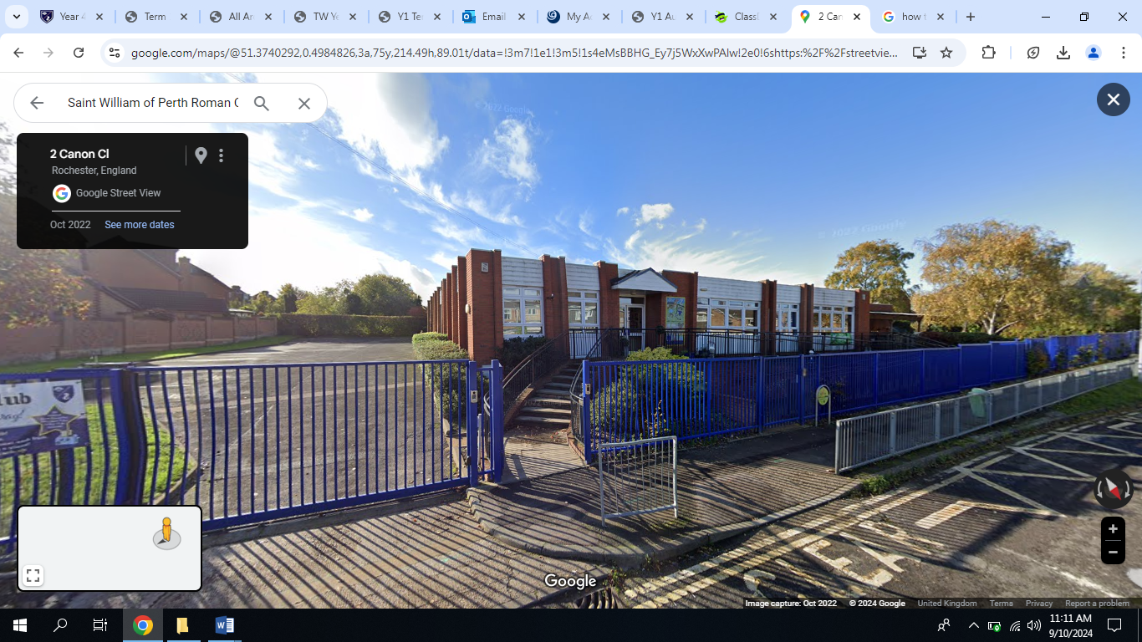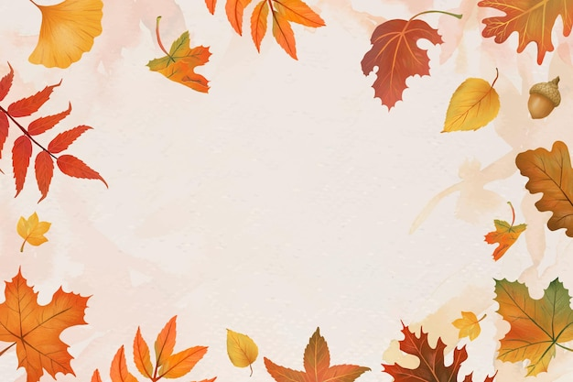

Science

Animals, including humans – All About Me

We will be naming parts of the human body and understanding what those body parts enable us to do. We will then be exploring all of the five senses and how they help us.

Computing

Computing Systems and Networks: Technology Around Us

We will begin to understand how technology helps us. We will start to become familiar with the different components of a computer and develop keyboard and mouse skills. We will also consider how to use technology responsibly.

RE

God’s Great Plan

We will be learning how God made the world and how he chose what would go in the world. We will be reflecting on how God loves us and our responsibilities to look after God’s world.

Topic

We will be exploring our local area and creating maps of our school. We will also consider and draw our route from home to school and think about the permanent and temporary things we see on our journeys. We will take a walk around our local area and discuss features we like and dislike and consider the different physical and human features. We will also be learning the names of the four countries and capital cities of the United Kingdom and begin to recognise some of the key landmarks of each country and capital city.

Art, Design technology, PE and Music

DT - We will design and create a building from our local area and experiment with joining materials together. We will then evaluate the final product.

Art - We will be creating artwork in the style of Andy Goldsworthy.

PE:

Indoor – Dance

Outdoor – Fundamental skills

Music - Music Express units: ‘Ourselves’ and ‘Number’ Exploring how to change sounds; recognising a steady beat; to understand how to control tempo.

English

Our main text for this term will be ‘The Jolly Postman’ by Janet and Allan Ahlberg. We will be writing for a range of purposes in response to this text, for example writing descriptively, composing letters, creating advertisements and writing invitations.

The children will be encouraged to become more independent with their writing. We will be focusing on basic sentence composition, using capital letters, fingers spaces and full stops, and using our knowledge of phonics for spelling.

We will have daily phonics sessions to support our reading and spelling.

Maths

Place Value within 10:

* Sorting and counting objects
* Representing numbers
* One more and one less
* Comparing objects and numbers using ‘more’, ’less’ or ‘equal to’ and the associated symbols.
* Ordering objects and numbers.

We will also begin to look at Addition and Subtraction within 10:

* Adding more
* The addition symbol
* Number bonds within and to 10

**Our Local Area**

What do you think about where we live?